**MTX Connect Rudrapur**

**3-4 October 2024: Ark Hotel & Resorts, Rudrapur**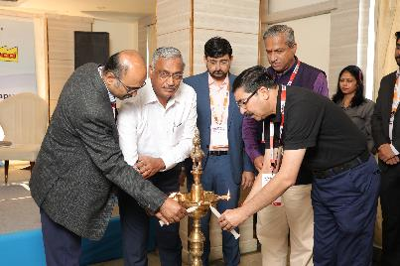

Indian Machine Tool Manufacturers’ Association (IMTMA) organized the second edition of MTX Connect in Rudrapur from 3 to 4 October 2024 to bring cutting-edge technologies directly to the regions in and around Rudrapur. The unique two-day tabletop expo attracted 46 exhibitors and around 550 registered visitors, creating a vibrant platform for networking and collaboration.

Biswajit Mazumdar - Plant Head, Ashok Leyland Limited, Ashok Bansal - President, Kumaun Garwal Chamber of Commerce & Industry, Kashipur, Shreekar Sinha - President, SIDCUL Entrepreneur Welfare Society, Pantnagar, and Pandurang Chavan - Plant Head, Mahindra & Mahindra Limited graced the inauguration with their presence.

Nisha Lobo, EC Member IMTMA, Jibak Dasgupta, Director General & CEO - IMTMA, and Guru Prasath K.R. - Executive Director - IMTMA attended the inauguration.

Rudrapur, located in Uttarakhand, is a prominent industrial hub with the presence of various industries like automotive, electronics, food processing, pharmaceuticals, etc. The area is also supported by a well-established infrastructure, including industrial estates and special economic zones, offering modern facilities and business incentives.

The expo was yet another effort by IMTMA to bring technologies and solutions to the doorsteps of industries located in various geographic regions, especially, MSMEs. Eminent industry representatives shared their views about the industrial ecosystem in and around Rudrapur and threw light on the opportunities that the machine tool industry could explore.